**5.DEMONSTRATE INFRASTRUCTURE AS A SERVICE(IAAS) BY CREATING A VIRTUAL MACHINE USING A PUBLIC CLOUD SERVICE**

**PROVIDER(AZURE/GCP/AWS) CONFIGURE WITH MINIMUM CPU,RAM AND STORAGE AND LAUNCH THE VM IMAGE.**

**AIM:**

**Procedure:**

**Implementation:**

**STEP1:CREATE AN ACCOUNT IN MICROSOFT AZURE.**

**STEP2: GOTO RESOURCE GROUP AND CREATE A RESOURCE GROUP.**

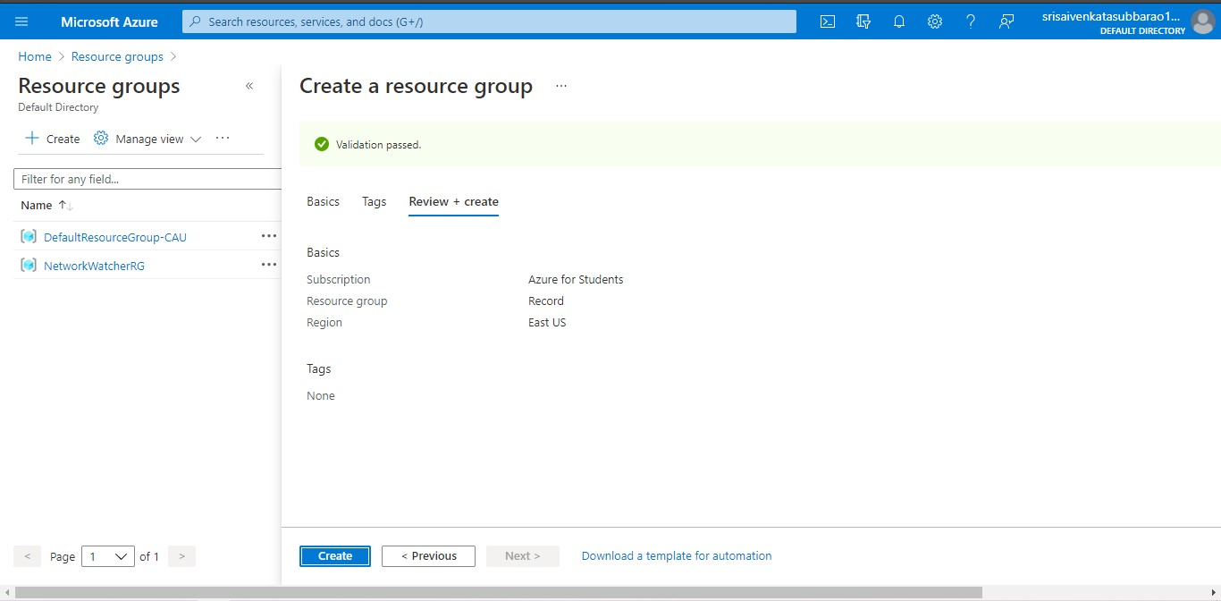

**STEP3: GIVE NECESSARY THINGS FOR RESOURCE GROUP.**

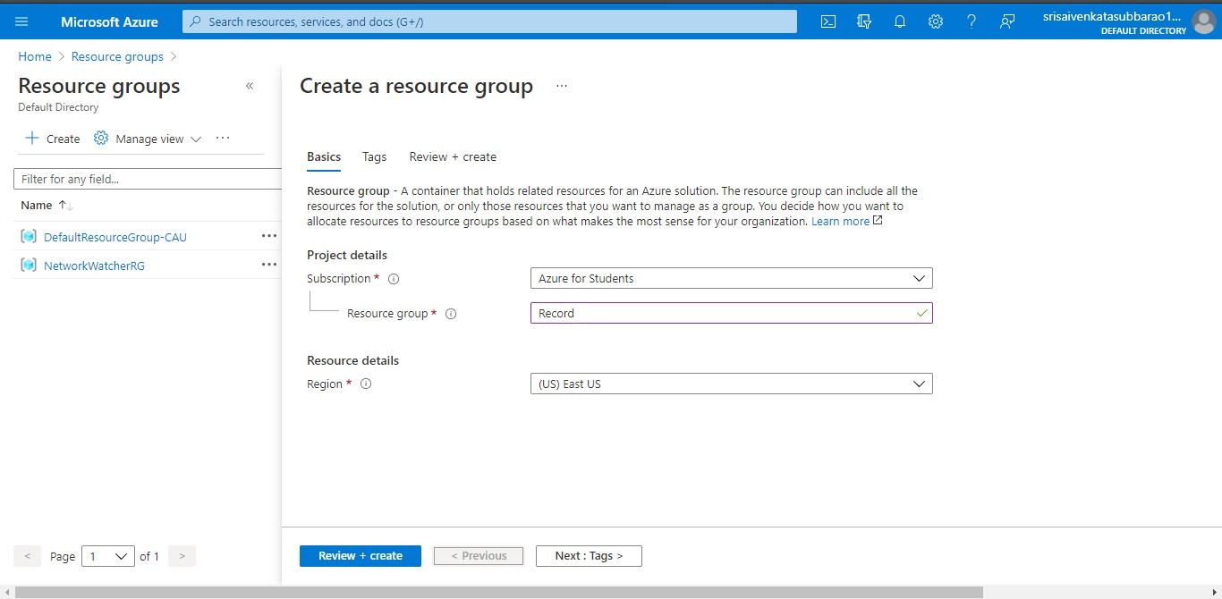

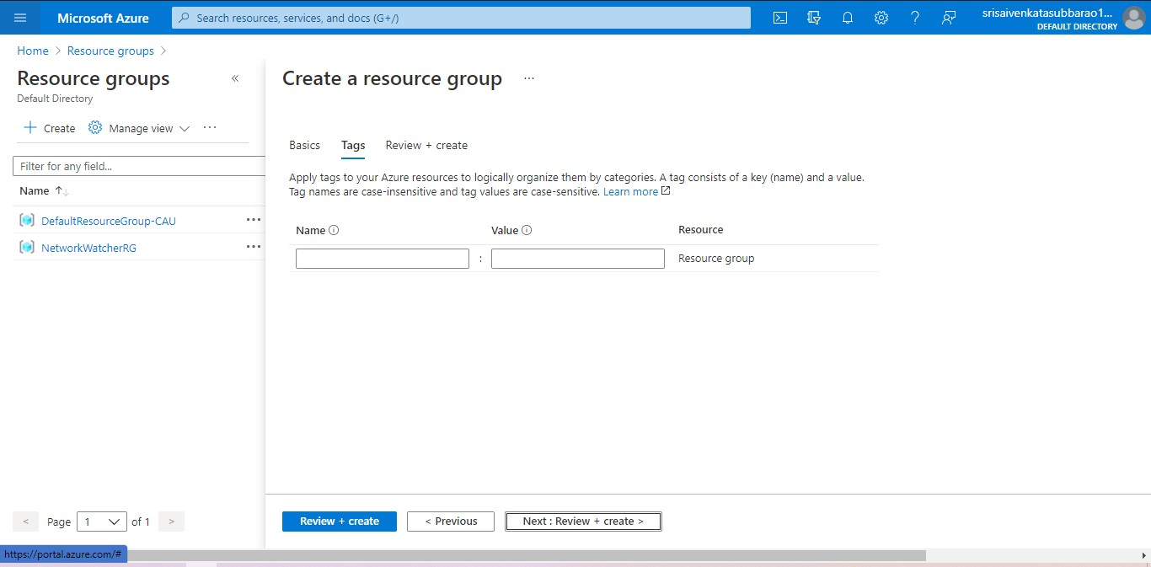

**STEP4: CREATE A VIRTUAL NETWORK FOR TO CREATE A VIRTUAL MACHINE .**

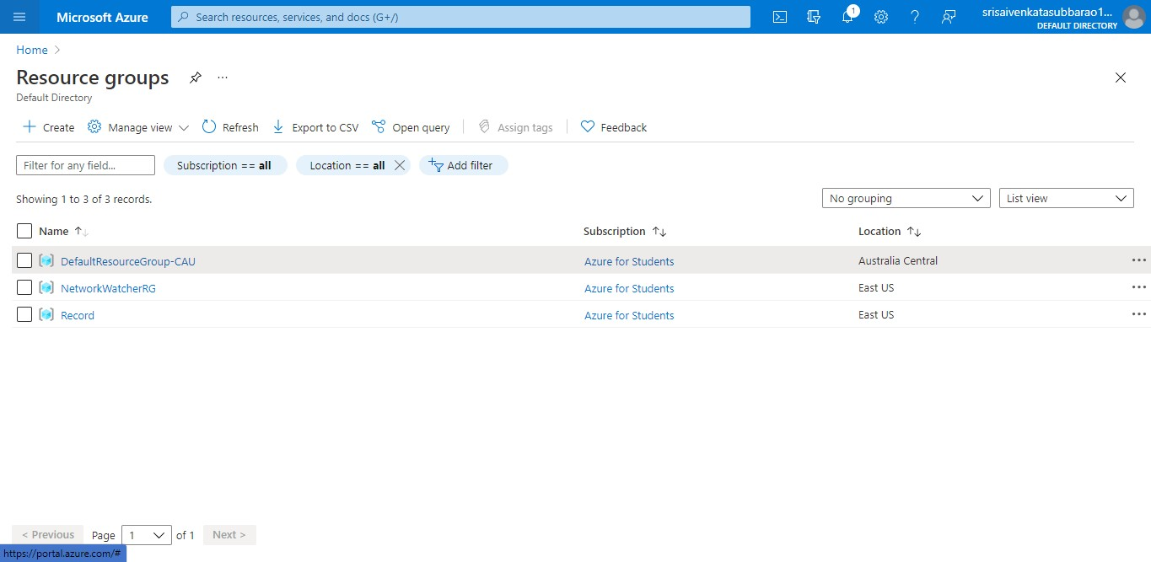

**STEP5: NOW CREATE A VIRTUAL MACHINE WITH UR IP ADDRESS AN USERNAME AND PASSWORD FOR YOUR VIRTUAL MACINE.**

**STEP6: AND YOUR VIRTUAL MACHINE IS DEPLOYED.**

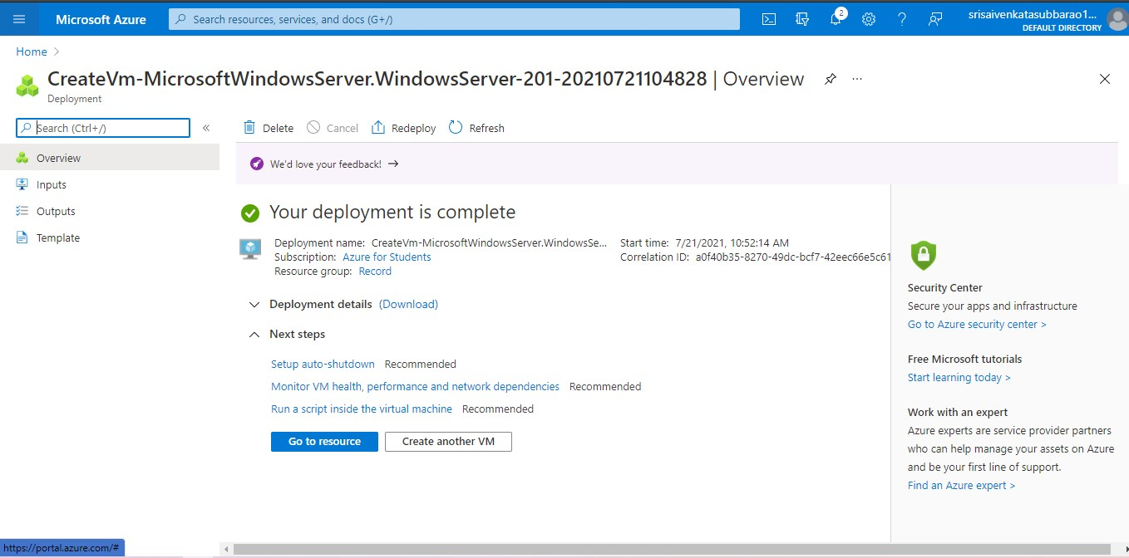

**STEP7: NOW CONNECT THE VIRTUAL MACHINE AND DOWNLOAD THE RDP FILE TO OPEN YOUR WINDOWS VIRTUAL MACHINE.**

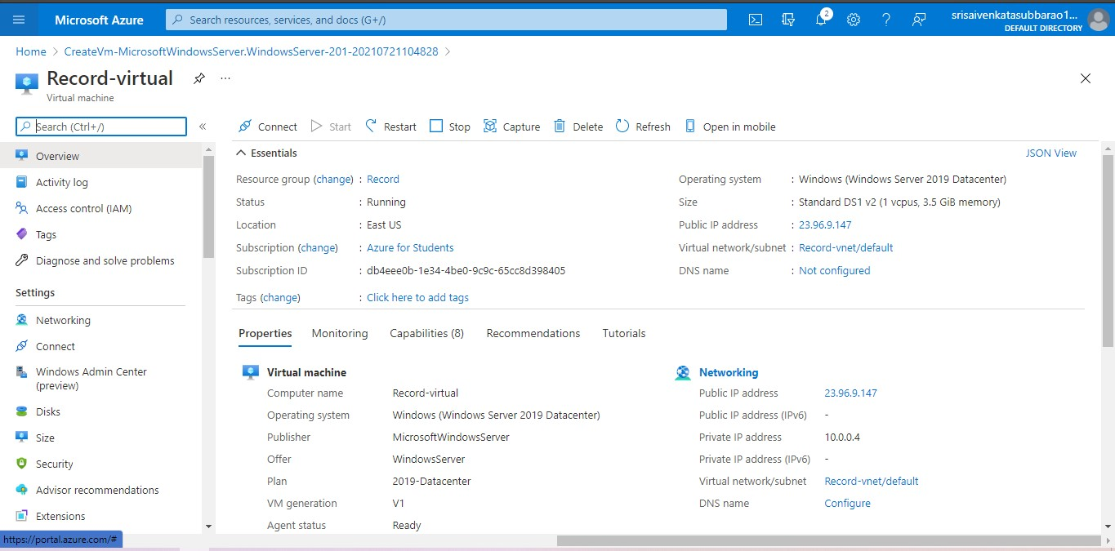

**STEP8: CREATED A NEW WINDOWS VIRTUAL MACHINE.**

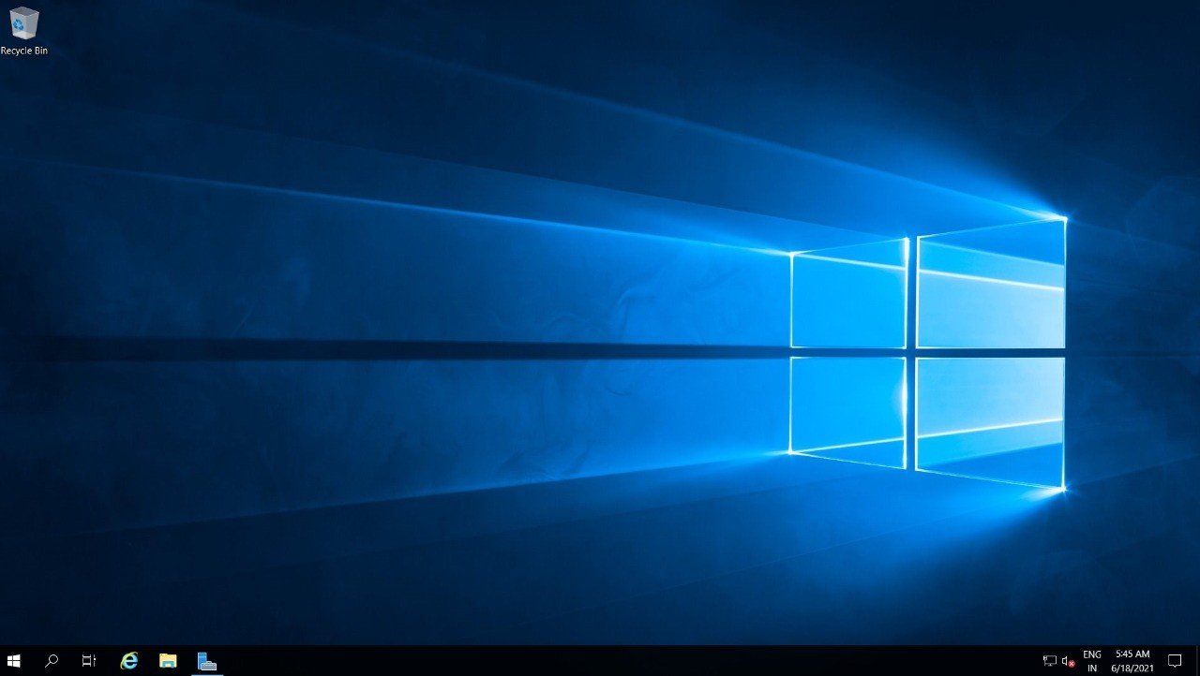

**RESULT:**